Raoult’s Law
The Raoult‟s law states “For a solution of two volatile liquids, the vapour pressure of each liquid in the solution is less than the respective vapour pressure of the pure liquids and the equilibrium partial vapour pressure of the liquid is directly proportional to its mole fraction.
For a solution containing two liquids A and B, the partial vapour pressure of liquid A is
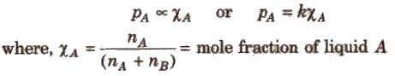
The proportionality constant is obtained by considering the pure liquid when χ_{A}= 1 then k = P°_{A}, the vapour pressure of pure liquid, hence
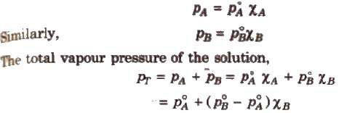

Ideal Solutions
Those solutions in which solute-solute (B-B) and solvent-solvent (A-A) interactions are almost similar to solvent solute (A-B) interactions are called ideal solutions. These solutions satisfy the following conditions :
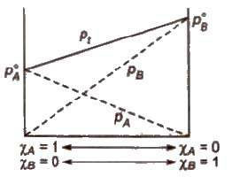
(i) Solution must obey Raoult‟s law, i.e.,
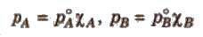
(ii) ΔHmix = 0 (No energy evolved or absorbed)
(iii) ΔVmix = 0 (No expansion or contraction on mixing)
Some solutions behave like nearly ideal solutions, e.g., benzene + toluene. n-hexane + nheptane, ethyl iodide + ethyl bromide, chlorobenzene + bromobenzene.

Non-ideal Solutions
Those solutions which shows deviation from Raoult‟s law is called non-ideal solution.
For such solutions,
ΔHmix ≠ 0
ΔVmix ≠ 0

(a) Non-ideal solutions showing positive deviation
In such a case, the solvent solute (A – B) interactions are weaker than solvent-solvent (A – A) or solute-solute (B – B) interactions and the observed vapour pressure of each component and the total vapour pressure are greater than that predicted by Raoult‟s law.
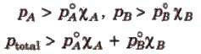
For such solutions
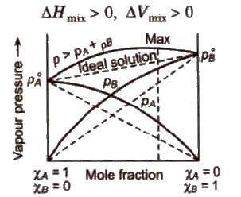

(b) Non-ideal solution showing negative deviation
In such a case, the A – B interactions are stronger than A – A or B – B interactions and the observed vapour pressure of each component and the total vapour pressure are lesser than that predicted by Raoult‟s law.
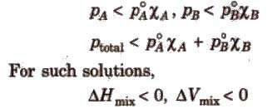
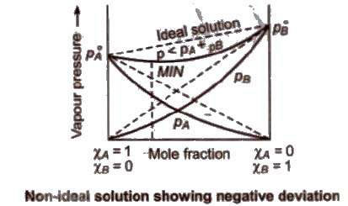
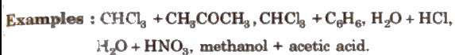

Azeotropic Mixture
A mixture of two liquids which boils at a particular temperature like a pure liquid and distils over in the same composition is known as constant boiling mixtures. These are formed by nonideal solutions.
(i) Minimum boiling azeotropes
are formed by those liquid pairs which show positive deviation from ideal behaviour. Such azeotropes have boiling points lower than either of the components, e.g., C₂H₅OH (95.57%) + H2O (4.43%)(by mass).
(ii) Maximum boiling azeotropes
are formed by those liquid pain; which show negative deviation from ideal behaviour. Such azeotropes have boiling points higher than either of the components. e.g., H₂O(20.22O%)+ HCl (79.78%] by mass.

